MANSI UNIYAL

19EE10039

**Experiment 4**

___________________________________________________________________________________

PART A: TRIGGERING CIRCUIT

Section 1:

1.

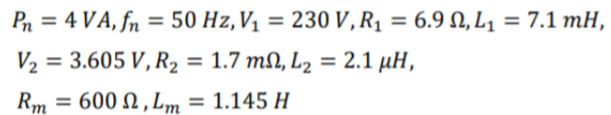

Vo = 185V and Vin (RMS) = 230V

𝑉𝑜𝑢𝑡= (𝑉𝑚/𝜋)*(1+cos 𝛼)

𝛼 = cos^−1 ( (185∗𝜋)/(230√2) − 1)

So, the firing angle = 38.1 degrees

Vref = 3.605 √2 * cos 𝛼 = 4.107 V

Vout(avg) =183.8 V

Load current: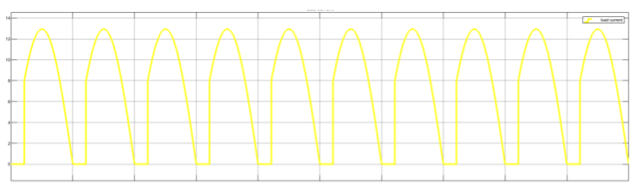

Load voltage:

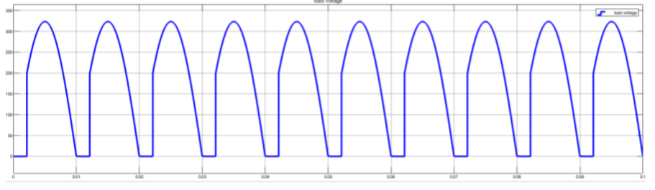

2.

Gate Pulse 1 w.r.t the cosine and reference signal:

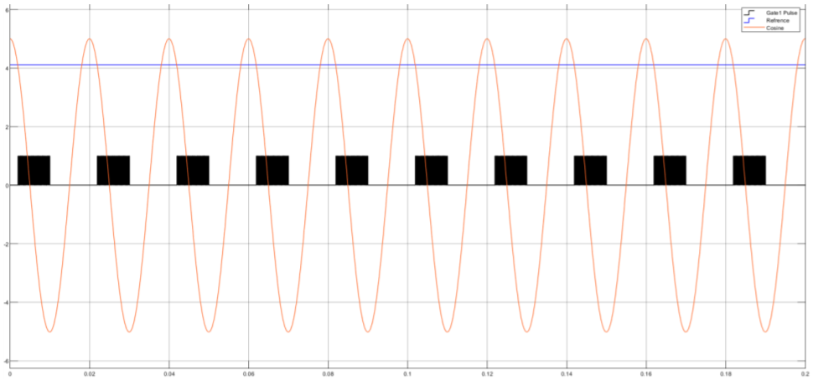

Gate Pulse 3 w.r.t the cosine and reference signal:

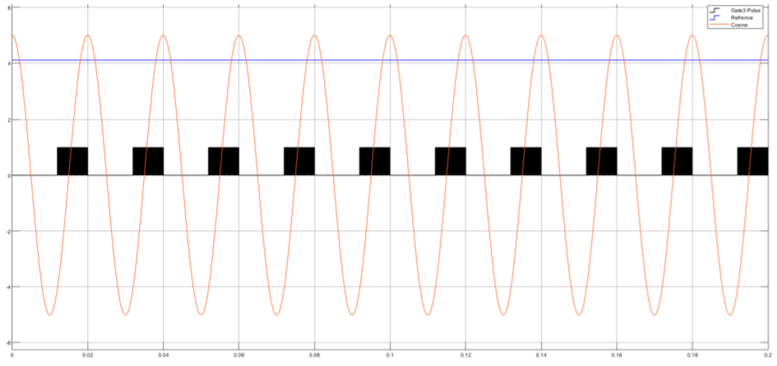

Observation:

● Thyristor 1 triggers when Vin is in the +ve half cycle after firing angle 𝛼.

● Thyristor 3 triggers when Vin is in the -ve half cycle after firing angle 𝛼.

3.

Firing time = 2.060 ms

Firing angle = 37.08 degree

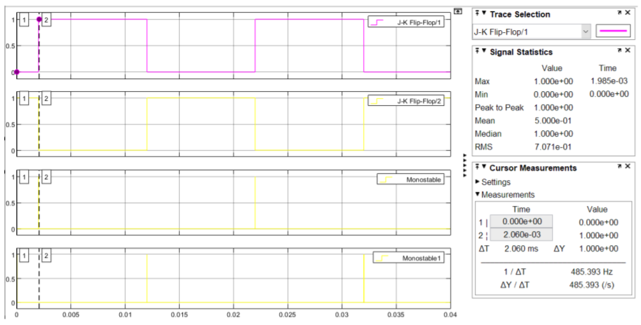

___________________________________________________________________________________

___________________________________________________________________________________

Section 2:





1.

𝑉𝐶𝐶 × 𝑇𝑝𝑢𝑙𝑠𝑒 = 𝑉𝑍 × 𝑇𝑑𝑒𝑚𝑎𝑔

𝑇𝑝𝑢𝑙𝑠𝑒 is 50% of the time period

Duration of 𝑇𝑑𝑒𝑚𝑎𝑔 is 30% of the time period of the gate pulse generated by the control circuit Vzener= 33.34V

2.

Vgk and primary current:

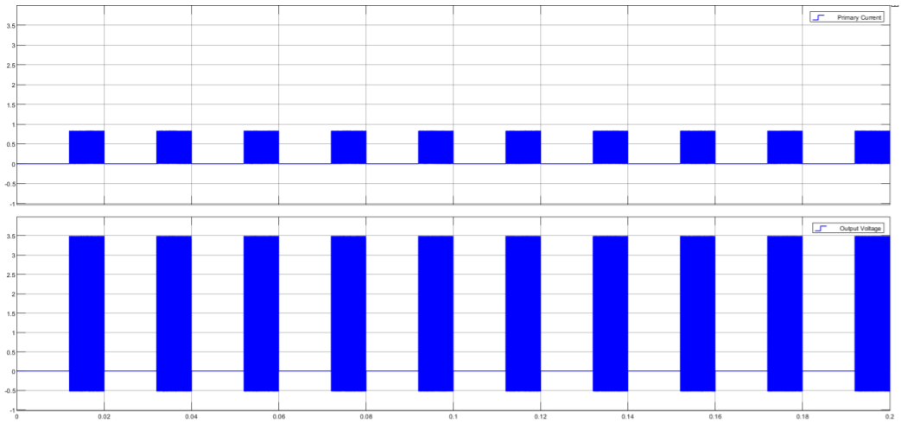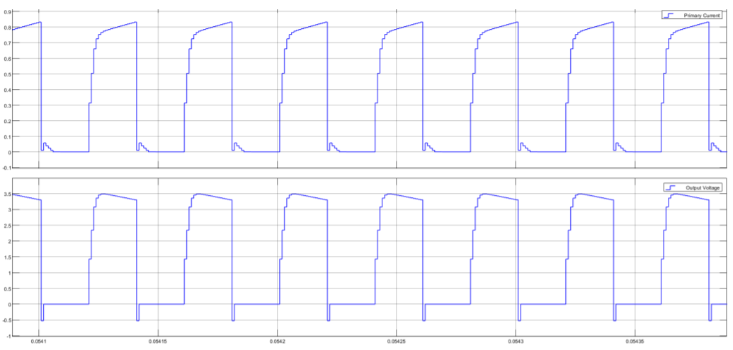

Primary Voltage and Secondary Voltage:

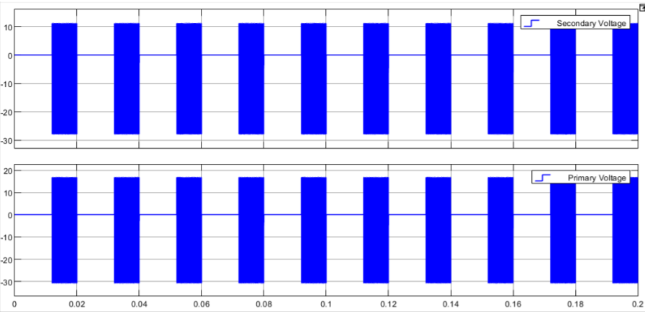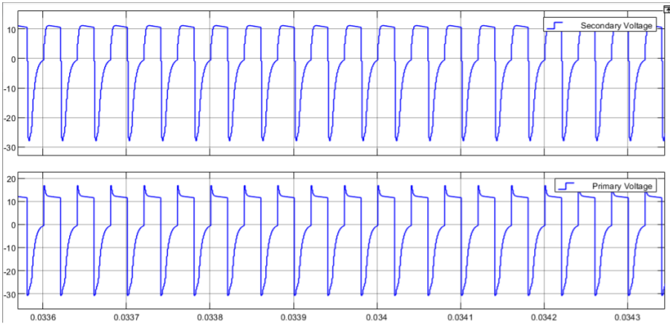

___________________________________________________________________________________

PART B: FULL CONTROLLED CONVERTER

1.

Without source inductance and freewheeling diode for L= 60 mH.

Vin = 230V

𝛼=30

𝑉𝑜𝑢𝑡 = 𝟐√𝟐 𝝅 ∗ 𝟐𝟑𝟎 ∗(cos 30) = 179.33𝑉

𝑅𝐿𝑜𝑎𝑑 = 𝟏𝟕𝟗.𝟑𝟑 𝟖 = 22. 42 Ω

𝑉𝑟𝑒𝑓 = 3.605 * √𝟐 ∗ 𝒄𝑜𝑠 30 = 4.414𝑉

VDC = 183.8V

IDC = 8.32A

2.

With 2.5 mH source inductance,

VDC = 183.8V

IDC = 8.32A

Overlap angle (μ) = (360/20ms)*(27.380us) = 0.49

3.

Voltage drop due to source inductance: (179.1-177.9) V = 1.2 V 4.

4.

With Freewheeling diode in the same circuit:

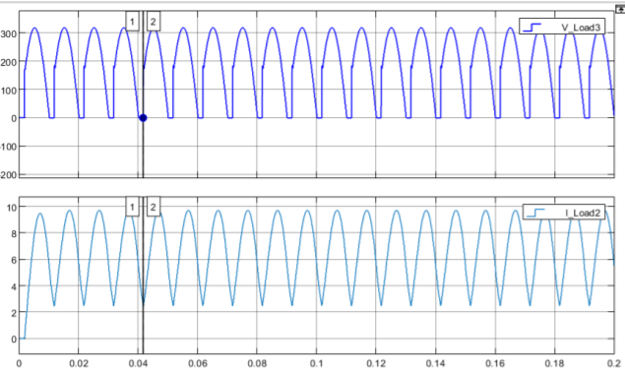

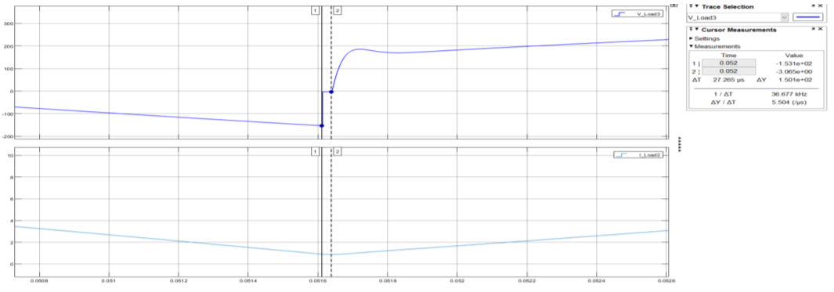

| Parameter | Load voltage (V)  Ideal case | Load voltage (V) With source inductance | Load voltage (V) With source  Inductance and freewheeling diode |
| --- | --- | --- | --- |
| Firing angle  (Degree) | 30 | 30 | 30 |
| Average load  Voltage (V) | 183.9 | 183.8 | 183.8 |
| Average load  Current (A) | 8.32 | 8.316 | 8.31 |
| Input rms  current (A) | 9.98 | 9.94 | 9.948 |
| Fundamental  Input current | 13.86 | 13.84 | 13.84 |
| Distortion factor | 0.9998 | 0.99984 | 0.9998 |
| THD (%) | 19.59% | 18.07% | 18.15% |
| Dpf | 0.867 | 0.866 | 0.866 |
| Pf | 0.867 | 0.866 | 0.867 |
| P1 (W) | 2202.248 | 2202.25 | 2202.24 |
| Q1 | 997.6 | 998.87 | 1030.77 |
| S1 | 1971.43 | 1945.78 | 2002.85 |

___________________________________________________________________________________

PART C: Asymmetric half-controlled converter

5.

𝑉𝑜𝑢𝑡 = (𝑉𝑚 / 𝜋)*(1+cos 𝛼) = 193.2V

a)

For firing angle α = 30°,

Simulated average Vout =190.2 V

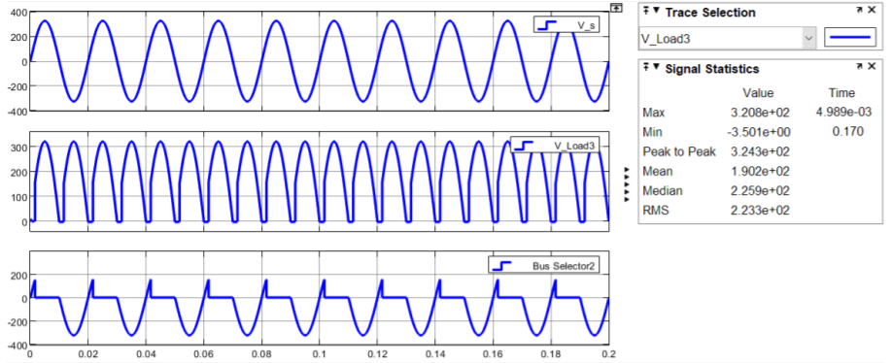

b) Thyristor 1 (RMS value) = 4.658 A

Thyristor 3 : RMS value = 4.722 A

Diode 2 (RMS value) = 4.855 A

Diode 4 (RMS value) = 4.839 A

c)

Source reactance drop of 5% of rated line voltage

The firing angle α = 30°.

Vm = 0.95*230* 2 = 309 V

𝑉𝑜𝑢𝑡 = (𝑉𝑚 / 𝜋)*(1+cos 𝛼) = 183.54 V

2.



Without Free Wheeling Diode With Free Wheeling Diode :

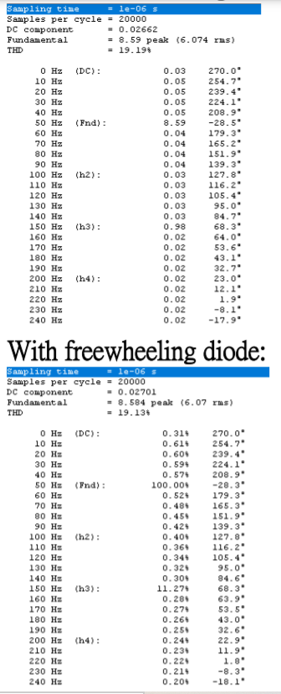 

___________________________________________________________________________________

___________________________________________________________________________________

DISCUSSIONS:

QS1.

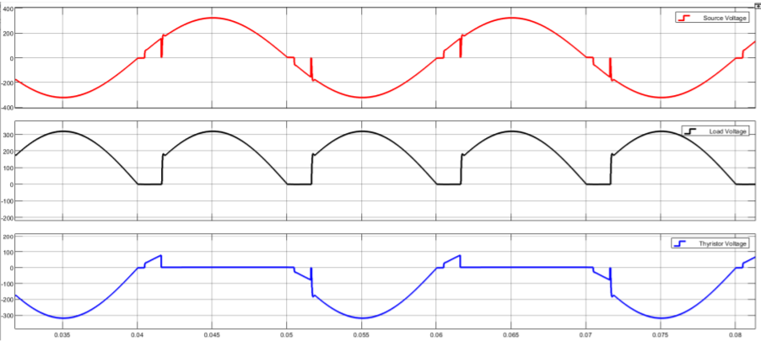

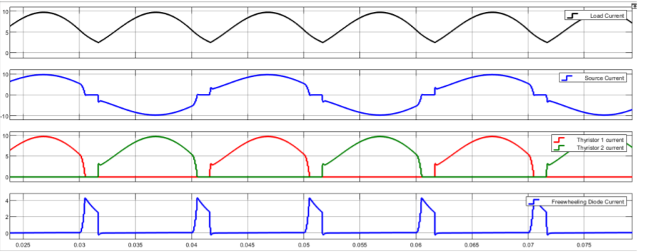

___________________________________________________________________________________

QS. The study between full-controlled and Asymmetric half-controlled converter in terms of load voltage, source current, power factor, THD.

Ideal cases considered : For a Full controlled converter :

R = 22.4 OHM , L = 60mH, Vin(RMS) = 230 V ,50hz, 𝛂=30°

Asymmetric half controlled converter :

R = 22.4 OHM , L = 60mH, Vin (RMS) = 230 V ,50hz, 𝛂=30°

Asymmetric Half Controlled gives a greater output voltage and an improved power factor as compared to the Full-Controlled. Asymmetric Half Controlled gives a greater output voltage and an improved power factor as compared to the Full-Controlled.

| Parameters | Full-Controlled | Asymmetric Half Controlled |
| --- | --- | --- |
| Load Voltage(AVG)(in V) | 179.2 | 190.8 |
| RMS Source Current (in A) | 8.452 | 8.61 |
| THD (%) | 11.55 | 17.66 |
| Power factor | 0.843 | 0.918 |
| Displacement factor | 0.845 | 0.934 |

___________________________________________________________________________________

QS. Why a train of pulses are used to turn on the thyristor instead of a single pulse?

The following are the reasons we use a train of pulses to turn on the thyristor instead of a single pulse:

If we hold the gate trigger voltage for a longer duration, it will cause huge dissipation of power within the thyristor and thus draw excess power from the circuit.

The thyristor may not latch on with the first firing pulse at the start of a conduction interval, as the current may not reach the minimum holding current.

Hence, we need to keep triggering on until it latches on.

___________________________________________________________________________________

QS. List key differences between asymmetric and symmetric semi-controlled rectifiers.

While the load current and the load voltage waveforms come out exactly the same for both the rectifiers, a difference in the Diode and Load current is observed.

Thyristor Currents: Asymmetric/Symmetric: Diode Currents: Asymmetric/Symmetric:

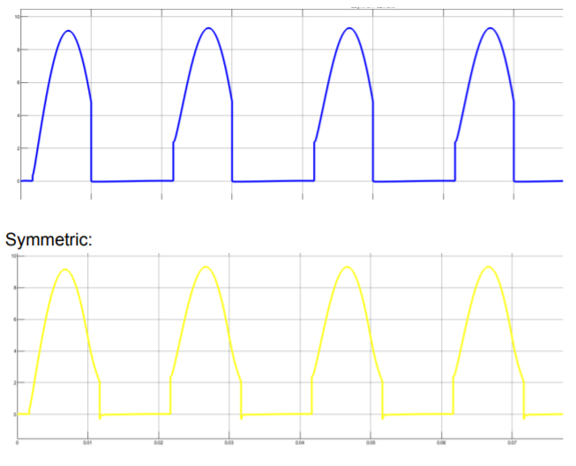 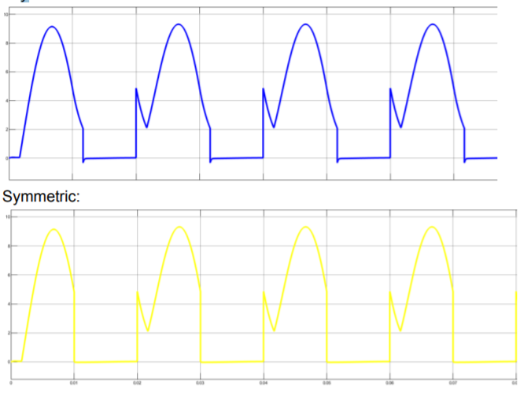

Observation :

* The conduction time for thyristor is more in symmetrical topology, thus higher RMS and average thyristor currents.
* The conduction time for the diode is less in symmetrical topology, thus lower RMS and average diode currents.
* From conduction time periods, we can also say that the average and RMS thyristor current is symmetrical configuration is higher. So SCR’s current rating should be higher in a symmetrical configuration.
* The average and RMS diode current in asymmetrical configuration is higher. So, the diode current rating should be higher in asymmetrical configuration. The freewheeling path in symmetrical configuration is through a (thyristor-diode) combination, and in asymmetrical configuration is through a (diode-diode) combination. This is because during freewheeling, devices belonging to the same leg will conduct in both configurations.